LAB Logbook

Github link: <https://github.com/Aswathy-alien/ML>

Lab 1

1) Create a vector using np.arange.

2) Change matrix a to 2-d array with 1 row. Print the array.

3) Save it in another array. Print the array.

4) Check the shape attribute value.

Lab2

Group by "relationship" and "hours-per-week".

Sid: 2261782, Where n=2

#### Reduce all "hours-per-week" column values ​​in the original DataFrame by subtracting the value 'n'. Use a function

#### Group ​​by "relationship" and reduced "hours-per-week".

Lab 3

Lab 4

MAE:

Lab 5

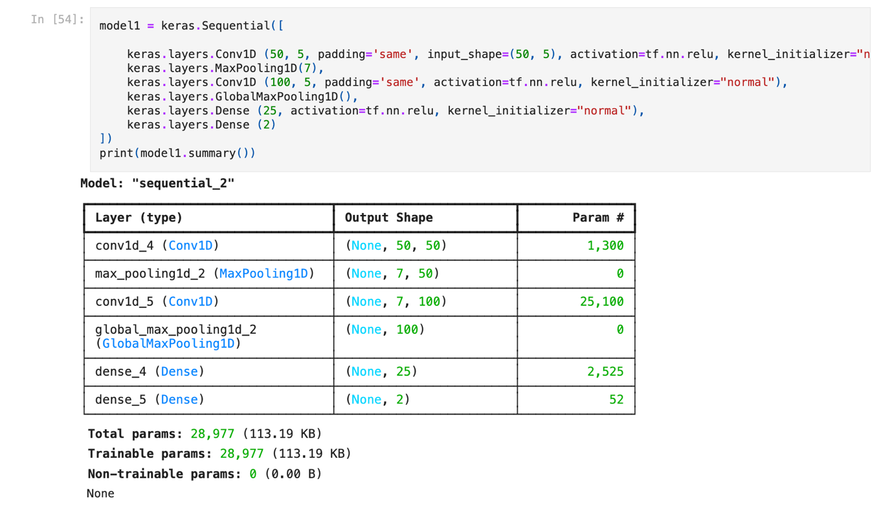

Lab 6

Output:

Lab 7

Lab 8

**MAE resulting graph during the training process**

**MAE detailed resulting graph during the training process**

Lab 9

Class test

Lab 10

Precision during training graph

More detailed Precision graph

Training accuracy graph

More detailed Accuracy graph

Lab 11

Create and train your own LSTM model

Adding all the LSTM's Error metrics

